# GOVERNMENT POLYTECHNIC COLLEGE MATTANNUR-670702

### (Department of Technical Education, Kerala)



**SEMINAR REPORT ON**

**AN TU TU BENCHMARK**

**SUBMITTED BY NIVED E K (Reg.No:19042510)**

**DEPARTMENT OF ELECTRONICS ENGINEERING**

**2021-22**

**GOVERNMENT POLYTECHNIC COLLEGE MATTANNUR-670702**

**(Department of Technical Education, Kerala)**



**CERTIFICATE**

*Certified that seminar work entitled* “ ***AN TU TU BENCHMARK*”***is a bonafide work carried out by* **“*NIVED E K*”** *in partial fulfilment for the award of Diploma in Electronics Engineering from Government Polytechnic College Mattannur during the academic year* 2021-2022.

### SeminarCo-ordinator Head ofSection

**InternalExaminer ExternalExaminer**

**DECLARATION**

I hereby declare that the report of *the* ***AN TU TU BENCHMARK*** work entitled which is being submitted to the Govt. Polytechnic College Mattannur, in partial fulfilment of the requirement for the award **of *Diploma in Electronics Engineering*** *i*s a confide report of the work carried out by me. The material in this report has not been submitted to any institute for the award of any degree.

Place:Mattannur **NIVED E K**

Date:

### ACKNOWLEDGMENT

I would like to take this opportunity to extend my sincere thanks to people who helped me to make this seminar possible. This seminar will be incomplete without mentioning all the people who helped me to make itreal.

Firstly, I would like to thank GOD, almighty, our supreme guide, for bestowing his blessings upon me in my entire endeavor.

I would like to express my deepest gratitude **Mr. M C PRAKASHAN** (Principal GPTC, Mattannur), **Mr. GEORGEKUTTI (**Head of Department of Electronics Engg.), for the help rendered by him to prepare and present this Seminar in proper way. Moreover I am very much indebted to **Mr. SREEJITH A** (Lecturer, Electronics Engg, seminar co-ordinator), for their advice.

I am also indebted to all my friends and classmates who have given valuable suggestion and encouragement.

**NIVED E K**

**ABSTRACT**

Nowadays the benchmarking tool is commonly used to benchmark phones and other devices to check the performance of the device itself. Here I concentrated on the area of mobile phones .In market there are large amount of mobile phones available in flagship rate , which is provided is very small budget for the normal people . Hence it is important to check the performance and the durability of the mobile phones. The process is simple. You can use An Tu Tu Benchmark to analyze the performance of your device. Each test gets a score that gives you an idea of the capability of your device. You can then compare your scores with those of other phones on the market to see how it ranks among them.

The AnTuTu benchmark is so common that some hardware manufacturers have cheated on the benchmark which makes the benchmark unreliable.In response to this, AnTuTu has created a new benchmark, called AnTuTu X, which makes it more difficult for manufacturers to cheat on the benchmark.

### TABLE OF CONTENTS

**CHAPTERNO TOPICS PAGENO**

Chapter1 INTRODUCTION……………………………………...9

Chapter2 HISTORY OF ORIGIN………………………………..10

Chapter2.1 BENCHMARK………………………………………...10

Chapter2.2 AN TU TU BENCHMARK……………………………11

Chapter3 WORKING…………………………………………….12

Chapter3.1 RANKING……………………………………………..12

Chapter3.2 COMPARING………………………………...……….13

Chapter3.3 EVALUATION………………………………………..14

Chapter4 AN TU TU SCORE……………………………………15

Chapter4.1 CPU SCORE…………………………………………...16

Chapter4.2 GPU SCORE…………………………………………...16

Chapter4.3 MEMMORY SCORE…………………………………..17

Chapter4.3 USER EXPERIENCE…………………………………..18

Chapter5 ADVANTAGES………………………………………...19 Chapter5.1 KEEP IMPROVING INTERNAL OPERATIONS. 19

Chapter5.2 UNDERSTAND WHAT WORKING AND WHAT ISN’T…………………………………………………...19

Chapter5.3 ADOPT OR IMPROVE UPON COMPITOR’S

PRACTICES…………………………………………....19

Chapter5.4 REDUCE COST BY INCREASING EFFICIENCY. 19

Chapter5.5 FOCUS ON PRACTICES AND OFFERING THAT

PROMOTE CUSTOMER SATISFACTION 19

Chapter6 DISADVANTAGES. 20

Chapter6.1 IT DOESN’T REALLY MEASURE

EFFECTIVENESS……………………………………..21

Chapter6.2 IT IS OFTEN TREATED AS A SOLO ACTIVITY. 21

Chapter6.3 THERE TENDS TO BE CERTAINLY LEVEL OF COMPLACANCY. 21

Chapter6.4 THE WRONG TYPE OF BENCHMARKING MIGHT BE

USED 21

Chapter6.3 IT CAN FOSTER MEDIOCRITY. 21

Chapter7 IMPORTANCE 22

Chapter8 BANNED. 23

Chapter8.1 WHY WAS AN TU TU BANNED. 23

Chapter8.2 THE MAIL SENT BY CEO OF AN TU TU. 24

Chapter9 REFERENCE. 25

Chapter10 CONCLUSION. 26

|  |  |  |
| --- | --- | --- |
| **FIGURE NO** | **LIST OF FIGURES**  **NAME** | **PAGE NO** |
| Fig 2.1    Fig 2.2  Fig 2.3  Fig 2.4  Fig 2.5 | BLOCK DIAGRAM OF METHOD OF BENCHMARKING...................................... ROBERT CRAMP………............................  A BOOK BY ROBERT CRAMP..............…  LOGO OF AN TU TU BENCHMARK…...  ASSOCIATION OF CHEETAH MOBILES.. | 10  11  11  11  11  11 |
| Fig 3.1  Fig 3.2  Fig 3.3  Fig 3.4 | BLOCK DIAGRAM OF WORKING  OF AN TU TU BENCHMARK.....…….…  FIGURE OF RANKING.................…....…  FIGURE OF COMPARING…….........…..  FIGURE OF EVALUATION……………. | 12  12  13  14 |
| Fig 4.1  Fig 4.2  Fig 4.3  Fig 4.4  Fig 4.5  Fig 4.6  Fig 4.7  Fig 4.8 | INTERFACE OF AN TU TU  BENCHMARK……………………………  BLOCK DIAGRAM OF AN TU TU  SCORE…………………………………….  FIGURE OF CPU………………………….  FIGURE OF GPU………………………...  FIGURE OF GPU PIN SLOTS…………...  FIGURE OF MEMORY………………….  FIGUE OF RAM…………………………..  FLOW CHART OF USER EXPERIENCE.. | 15  15  16  16  17  17  18  18 |
| Fig 7.1 | PROCESS OF BENCH MARKING……… | 21  22 |
| Fig 8.1 | TWEET BY AN TU TU ORGANISATION.. | 22 |

**LIST OF TABLES**

**TABLE NO NAME PAGENO**

|  |  |  |
| --- | --- | --- |
| Table 9.1 | PERFORMANCE RANKING OF |  |
|  | PROCESSORS................................................. | 25 |
| Table 9.2 | PERFORMANCE RANKING OF |  |
|  | FLAGSHIP MOBILES.............…………....... | 25 |

**CHAPTER 1**

**INTRODUCTION**

Benchmark is defined as a standard or point of reference against which things may be compared.In surveying, a "bench mark" (two words) is a post or other permanent mark established at a known elevation that is used as the basis for measuring the elevation of other topographical points.

Benchmarking means learning and bringing new ideas into companies. Companies can use benchmarking in different ways. Benchmarking enables companies to incorporate strategic planing and enhance business efficiency. Find- ings based on benchmarking help managers to provide better decision-making.

One of the most important things that a business who relies on software development can do is to establish a software performance benchmarking system. This is used to determine how a system performs when tested under a particular workload. It can test stability, responsiveness, effectiveness, speed or something else. It can also be used to investigate, measure, validate or verify other parts of your code, such as the scalability or usage. When establishing this benchmark, you can then use it to measure new developments, updates, or changes against into the future.

Benchmarking software is a software tool to gauge the various performance aspects of each device we review. It is observed that companies at times might be reluctant to use benchmarks. One of the most popular reason for this is the belief that they are their own organization, and hence, do not need to emulate any other organization. This is where it is critical to underline the fact that benchmarking does not mean blindly ‘copying’ what competitors do. It simply means to understand what is the acceptable standard in the industry, and where does the organization stand vis-à-vis that standard. Since why,AN TU TU benchmarking technique has started and benefited lots of people all over the world

**CHAPTER 2**

**HISTORY OF ORIGIN**

**2.1 Benchmark**

The term benchmark or survey benchmark originates from the chiseled horizontal marks that surveyors made in stone structures, into which an angle-iron could be placed to form a "bench" for a leveling rod, thus ensuring that a leveling rod could be accurately repositioned in the same place in the future.

In the early 1900's, benchmarking was still a process of business owners studying their competitors' techniques. In the mid-1900's, businesses began undertaking reverse engineering of competitor products.Later developed in industry in the early 1930s, benchmarking was conceptualized within a competitive world . Robert Camp, universally regarded as the founding father of the benchmark process, this bestseller is quite simply the definitive reference on the topic.

Modern benchmarking was started by Xerox Corp.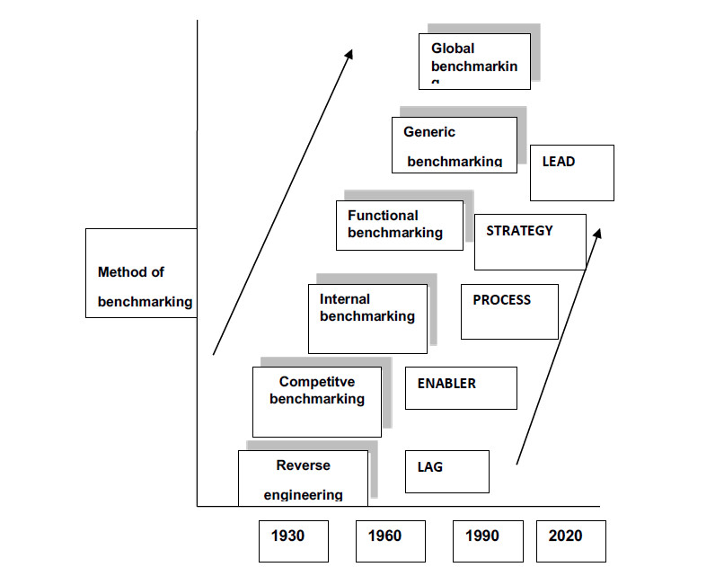The focus on process benchmarking continued and in the late 1980s two new phases emerged: strategic and global benchmarking.

Fig 2.1 Block diagram of method of benchmarking



Fig 2.2 Robert camp Fig 2.3A book about benchmarking by Robert camp **2.2 AN TU TU Benchmark**

AN TU TU benchmarking was found in 2011 by beijing AN TU TU technology company limited .The company developed the software in Chaoyng district, Beijing ,and was cofounded by Chinese entrepreneurs Shào Yīng (邵英) and Liáng Bīn (梁斌).It is owned by Chinese company called Cheetah Mobile.



Fig 2.4 Logo Fig 2.5 Association of cheetah mobiles

**CHAPTER 3**

**WORKING**



Fig3.1 Block diagram of AN TU TU benchmark working

The working of AN TU TU benchmarking is categorized into three area and they are Ranking, Comparing & Evaluating.

**3.1 Ranking**



Fig 3.2 Figure of rankings

A ranking is a relationship between a set of items such that, for any two items, the first is either "ranked higher than", "ranked lower than" or "ranked equal to" the second.In mathematics, this is known as a weak order of total pre-order of objects. It is not necessarily a total order of objects because two different objects can have the same ranking. The rankings themselves are totally ordered.

By reducing detailed measures to a sequence of ordinal numbers, rankings make it possible to evaluate complex information according to certain criteria.Thus, for example, an Internet search engine may rank the pages it finds according to an estimation of their relevance, making it possible for the user quickly to select the pages they are likely to want to see.

**3.2 Comparing**



Fig 3.3Figure of comparing

**C**omparing is the act of evaluating two or more things by determining the relevant, comparable characteristics of each thing, and then determining which characteristics of each are similar to the other, which are different, and to what degree. Where characteristics are different, the differences may then be evaluated to determine which thing is best suited for a particular purpose. The description of similarities and differences found between the two things is also called a comparison. Comparison can take many distinct forms, varying by field: Comparison has a different meaning within each framework of study. Any exploration of the similarities or differences of two or more units is a comparison. In the most limited sense, it consists of comparing two units isolated from each other.

To compare things, they must have characteristics that are similar enough in relevant ways to merit comparison. If two things are too different to compare in a useful way, an attempt to compare them is colloquially referred to in English as "comparing apple and orange." Comparison is widely used in society, in science and in the arts.

**3.3 Evaluation**



Fig3.4 Figure of evaluation

Evaluation is a systematic determination of a subject's merit, worth and significance, using criteria governed by a set of standards. It can assist an organization, program, design, project or any other intervention or initiative to assess any aim, realisable concept/proposal, or any alternative, to help in decision making; or to ascertain the degree of achievement or value in regard to the aim and objectives and results of any such action that has been completed.

The primary purpose of evaluation, in addition to gaining insight into prior or existing initiatives, is to enable reflection and assist in the identification of future change.Evaluation is often used to characterize and appraise subjects of interest in a wide range of human enterprises, including the art, criminal justice, foundation, non-profit organisations, government, healthcare, and other human services. It is long term and done at the end of a period of time.

**CHAPTER 4**

**AN TU TU SCORE**

AN TU TU gives your device an overall numerical score as well as individual scores for each test it performs. The overall score is created by adding the results of those individual scores. For example, if your device's score is 300000, a device with a score of 600000 is about twice as fast.You can use individual test scores to compare the relative performance of specific parts of different devices. For example, you could compare how fast your phone's storage performs compared to another phone's storage.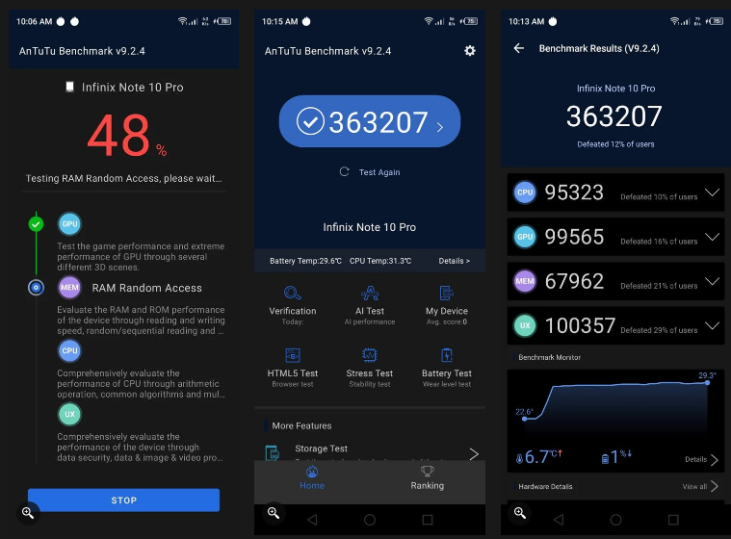However there are many factors that need to be considered while buying a smartphone; Antutu score is just one of them.

Fig 4.1 Interface of AN TU TU benchmark

AN TU TU score is further divided into 4 main category.they are cpu , gpu , memory and user experience. The AN TU TU benchmark software firstly calculate the individual score of the above categorize.

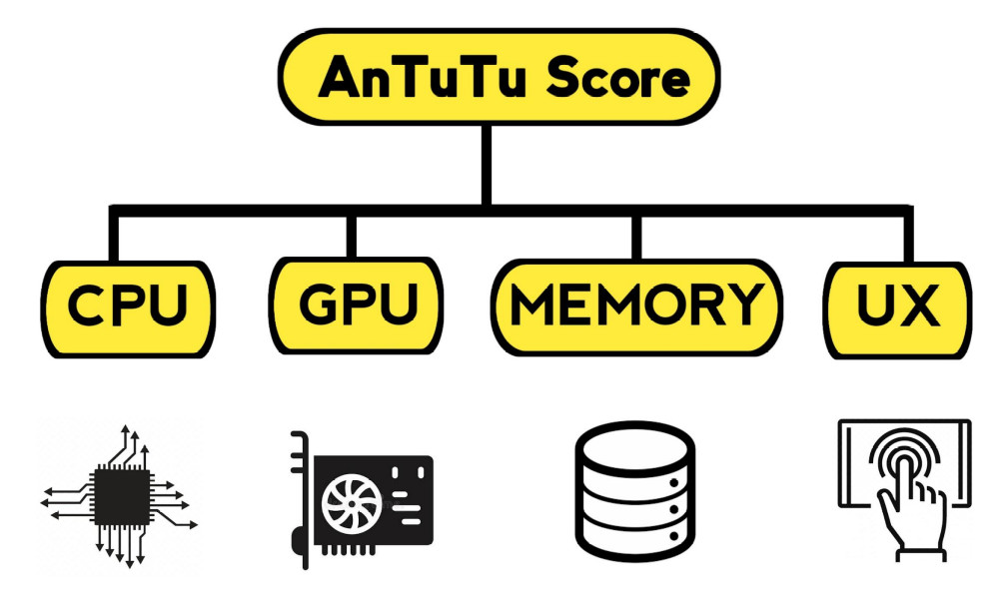

Fig 4.2 Block diagram of AN TU TU score

**4.1 Cpu score**

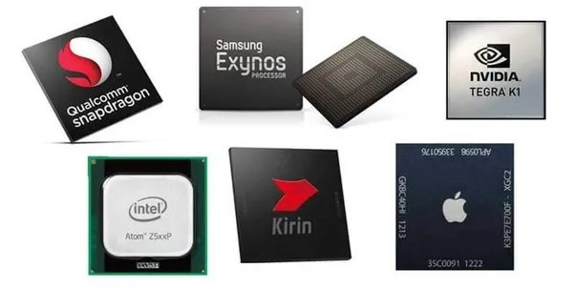

Fig 4.3 Figure of CPU

Central processing unit. The first part of the overall score is your CPU score. The CPU score in turn includes the output of CPU Mathematical Operations, CPU Common Algorithms, and CPU Multi-Core. In simpler words, the CPU score means how fast your phone processes commands. Your device's central processing unit (CPU) does most of the number-crunching. A faster CPU can run apps faster, so everything on your device will seem faster.

Of course, once you get to a certain point, CPU speed won't affect performance much. However, a faster CPU may still help when running more demanding applications, such as high-end games.

**4.2 Gpu score**

The second part of the overall score is your GPU score. This score is comprised of the output of graphical components like OpenGL and Vulkan, depending on your device.The GPU score means how well your phone displays 2D and 3D graphics. Your device’s graphics preocessing unit(GPU) handles accelerated graphics.

When you play a game, your GPU kicks into gear and renders the 3D graphics or accelerates the shiny 2D graphics. Many interface animations and other transitions also use the GPU.

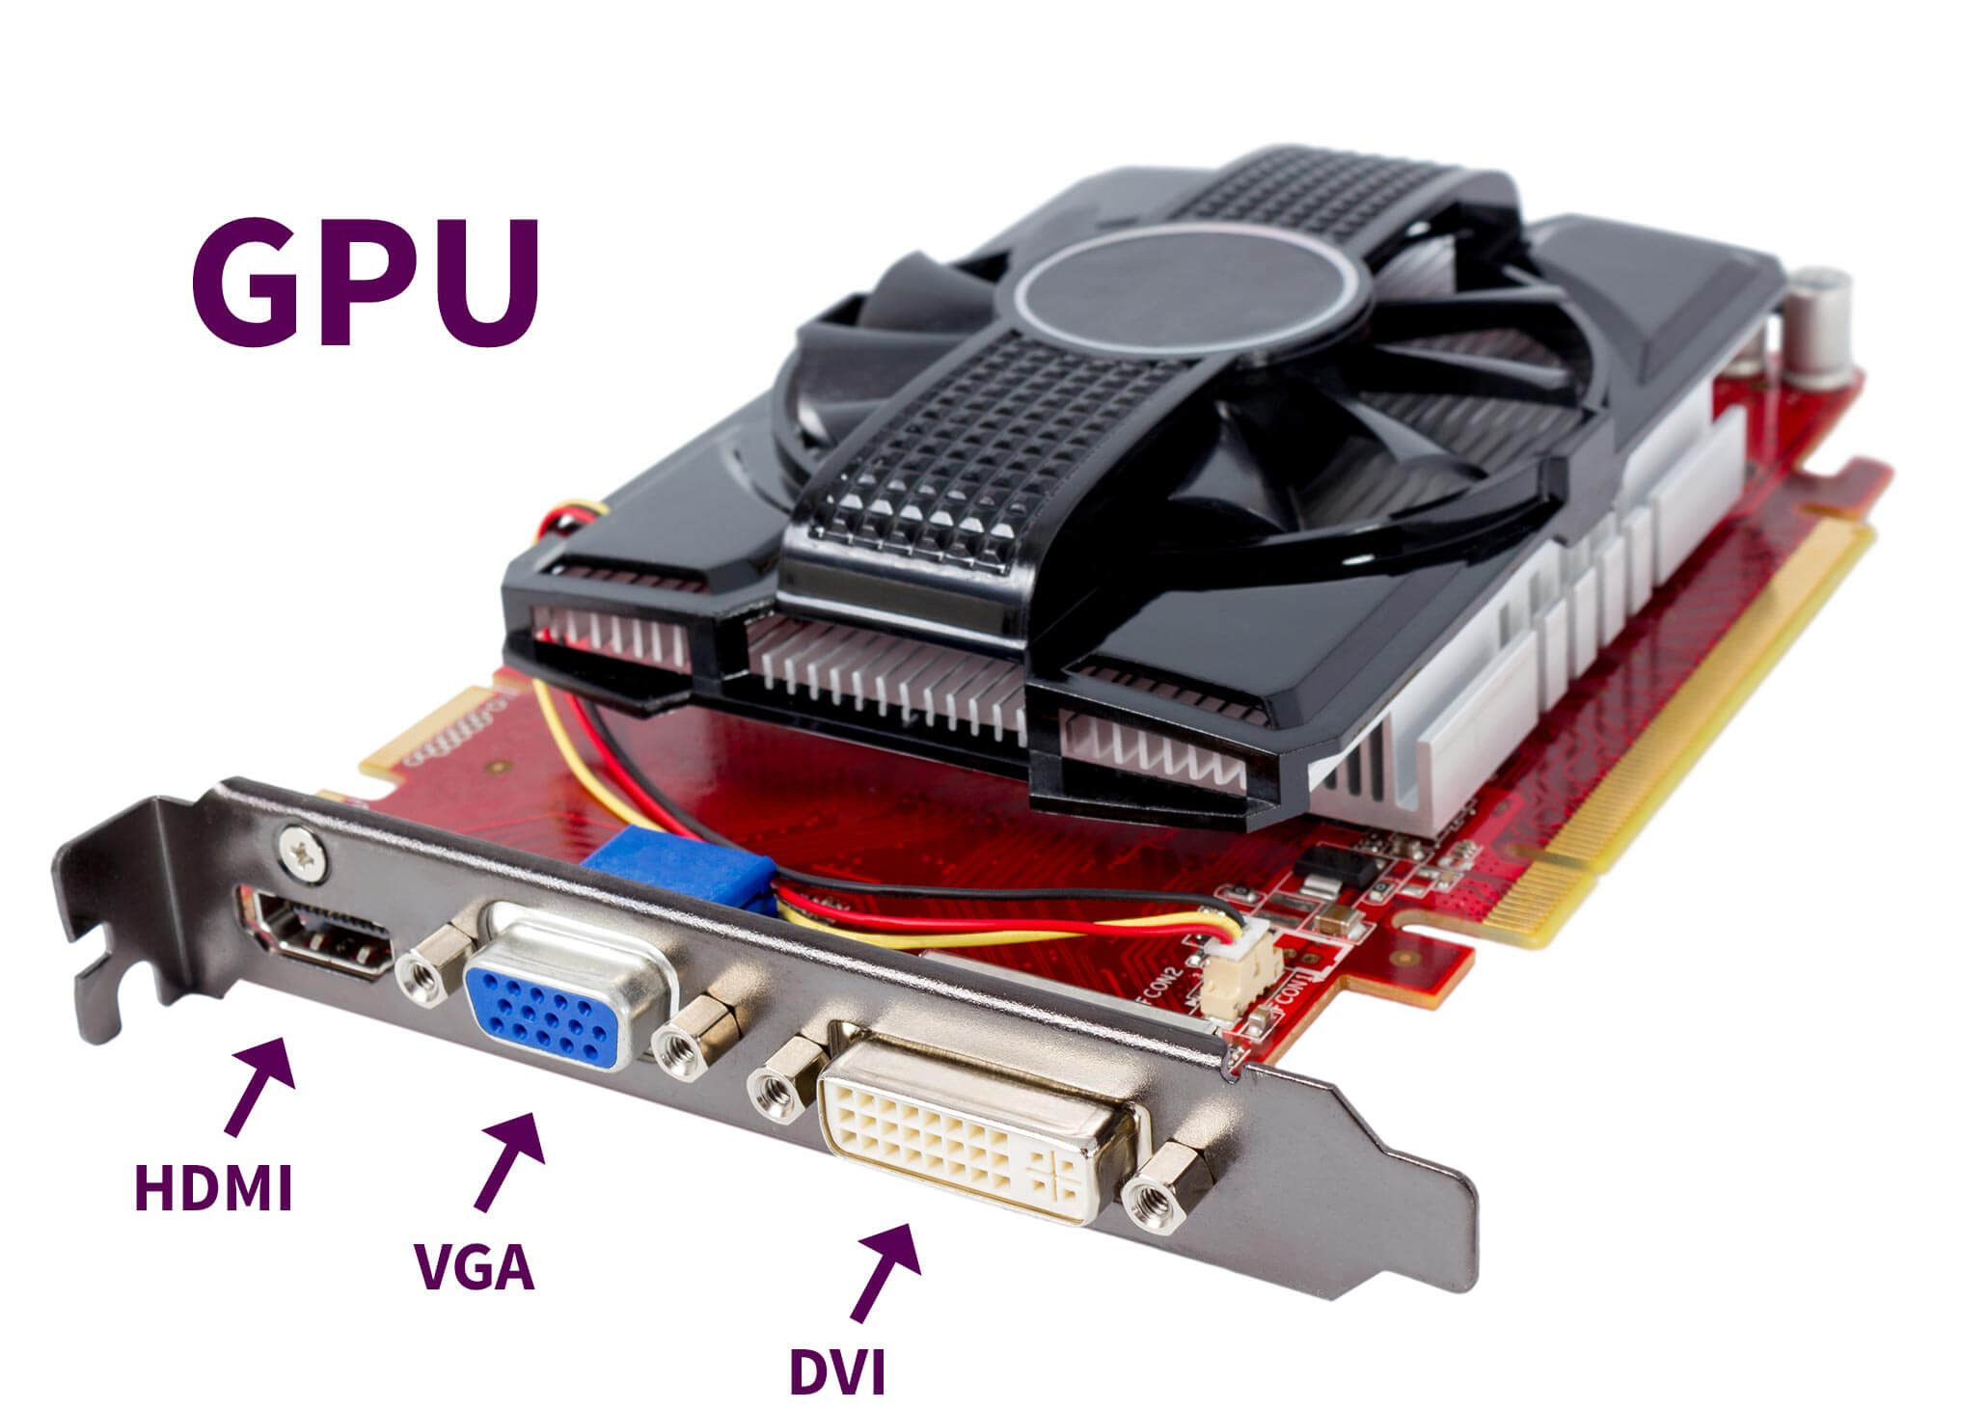

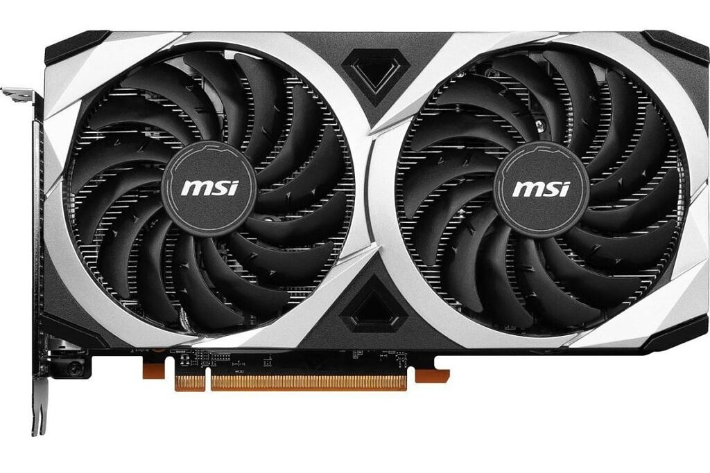

Fig 4.4 Figure of GPU Fig 4.5 Figure of GPU pin slots

The GPU is optimized for these sorts of graphics operations. The CPU could perform them, but it's more general-purpose and would take more time and battery power. You can say that your GPU does the graphics number-crunching, so a higher score here is better.

**4.3 Memmory score**

The third part of the overall score is your MEM score. The MEM score includes the results of the output of RAM Access, ROM APP IO, ROM Sequential Read and Write, and ROM Random Access.In simpler words, the AnTuTu MEM score means how fast and how much memory your phone possesses. RAM stands for random access memory; while ROM stands for read only memory.

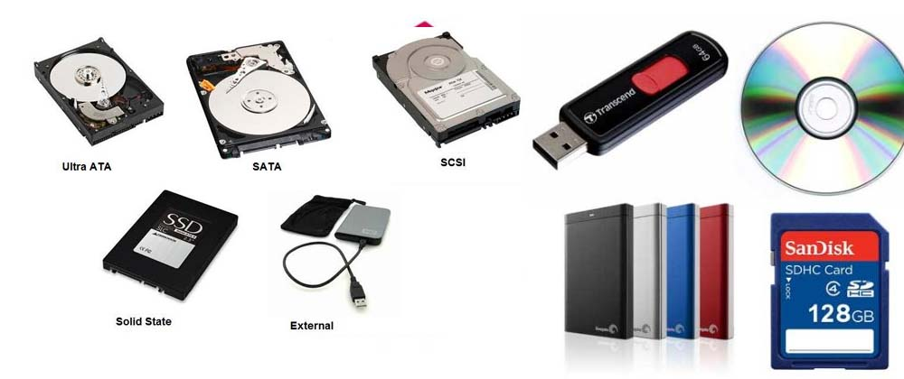

Fig 4.6 Figure of memmory

Your device uses RAM as working memory, while flash storage or an internal SD card is used for long-term storage. The faster it can write to and read data from its RAM, the faster your device will perform.

While RAM is volatile in nature, ROM is its opposite. RAM mostly stores temporary data, while ROM is used to store permanent data like the firmware of your phone. Both the RAM and ROM make up the memory of your phone, helping it to perform tasks efficiently.

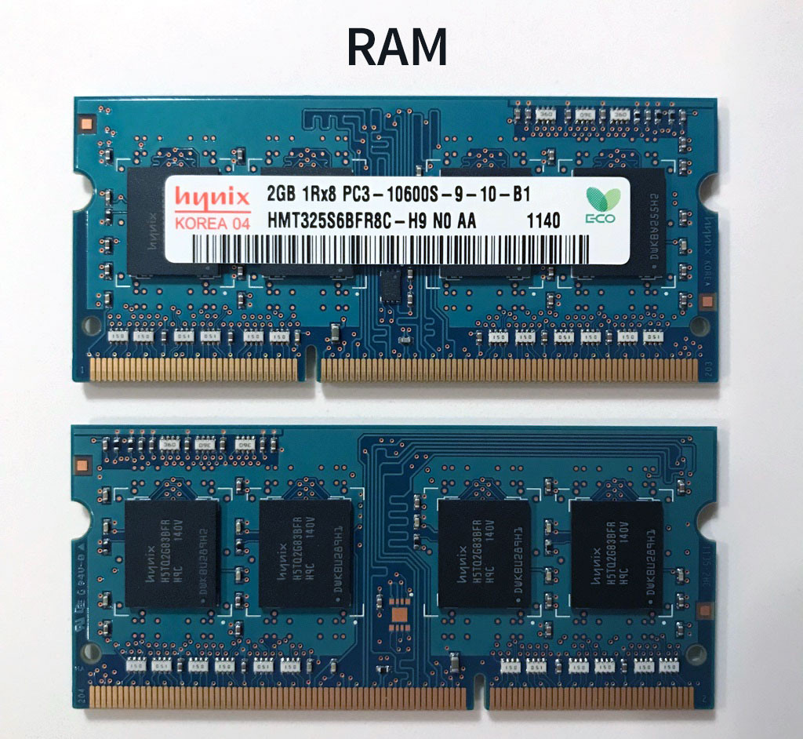

Fig 4.7 Figure of RAM

**4.4 User experience**

The fourth and final part of the overall score is your UX score. The UX score is made up of the results of the output of the Data Security, Data Processing, Image Processing, User Experience, and Video CTS and Decode tests.

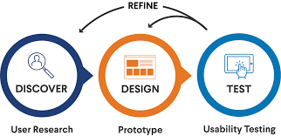

Fig 4.8 Flowchart of user experience

The UX score means an overall score that represents how the device’s “user experience” will be in real world. It's a number you can look at to get a feel for a device's overall performance without digging into the above benchmarks or relying too much on the overall score.If you were to rely on one of the four sub-scores to evaluate a phone, the UX score would be your best bet. UX—or user experience—is, as the name suggests, what ultimately matters when the phone is in your hand.

**CHAPTER 5**

**ADVANTAGES**

5.1 Keep improving internal operations

Benchmarking your processes and procedures, especially against internal standards, can help the company become more efficient and productive year over year.

5.2 Understand what’s working and what isn’t

A deep, thorough analysis of your system performance will allow you to identify trends and patterns that you may not have noticed as they were happening. Looking at this data will give you a clear picture of what behaviors and practices improve overall performance results and which ones don’t.

5.3 Adopt or improve upon competitors’ practices

When companies study their competition, they begin to understand what they’re doing that makes them successful, as well as areas where they falter. By adapting competitors’ best practices to the organization’s needs and deviating from the things customers or clients don’t like, you can optimize your position in the market and better appeal to your target audience.

5.4 Reduce costs by increasing efficiency

Benchmarking is most often used to improve performance through efficiency. Cutting out waste in your processes, be it monetary costs or time and effort spent, will help to streamline the operations and ultimately help you retain more of your revenue.

5.5 Focus on practices and offerings that promote customer satisfaction and loyalty Gathering feedback and data from customers (either your own or your competitors) will give you greater insight into what they like and don’t like, and what you can do to keep earning in the future.

**CHAPTER 6**

**DISADVANTAGE**

6.1 It doesn’t really measure effectiveness

When you’re instituting best practices, you are examining specific efficiencies under a microscopic lens. What you are not doing is measuring how effective your processes happen to be. You know why there are standards in place, but how were those standards attained in the first place? If there are any flaws in the process, you’re going to usually find out the hard way.

6.2 It is often treated as a solo activity

Benchmarking is important, but it can’t be the only thing a business does in order to institute change. It is simply part of the process that will help you reach an end goal. If there isn’t a vision in place, leadership that can bring people to that vision, or employees invested into the end goals, then benchmarking isn’t going to do much good. It will simply tell you that you’re failing at what you do.

6.3 There tends to be a certainly level of complacency

The biggest trap of benchmarking occurs when a business is able to exceed the standards of their competition. It is very common for businesses in such a position to stop striving for more innovation once they reach that point because there is a feeling like they are the best in the industry. To maintain that status, however, one must continually innovate, and the arrogance of a “win” can stop that from happening.

6.4 The wrong type of benchmarking might be used

There are 4 types of benchmarking: internal, competitive, functional, and generic. In broad terms, a business should use a combination of each for the best possible chance at success. Sometimes only one type of benchmarking is used and it isn’t the correct one to meet their goals. You can benchmark internal processes by comparing your products and services to the competition’s products and services.

6.5 It can foster mediocrity

The ultimate issue with benchmarking is the perspective behind it. If there is a certain arrogance that says an organization is already the best in the industry, then this bias will influence the data collected.

**CHAPTER 7**

**IMPORTANCE**

The pros and cons of benchmarking offer a relatively easy way to improve organizational processes, but it can also be a complex journey depending on what the desired outcome happens to be.Strategy

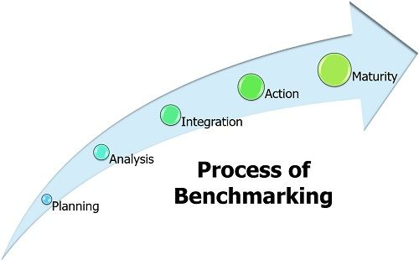

Fig 7.1 Process of benchmarking

* Structure
* Cost
* Skills
* Services
* Impact analysis
* Innovation
* Future trends
* Quality
* Productivity
* Launch
* Planning
* Life cycle insights

**CHAPTER 8**

**BANNED !!!**

Google has removed several apps due to the violation of one of its developer policy. Recently the softWare supergiant has removed one of the most popular benchmarking apps, AnTuTu, from Play Store.

## 8.1 Why was AnTuTu removed from Play Store?

According to many reports, the AnTuTu app was removed from Google Play Store allegedly over a misunderstanding. The tech giant also removed other AnTuTu benchmarking apps, including AnTuTu Benchmark, AnTuTu 3DBench and AlTuTu Benchmark February 2018.

 The reason behind the removal of the apps from the store is due to its affiliation with Cheetah Mobile. Cheetah Mobile has been violating Google's developer policy for a long time by outrageous data collection, displaying deceptive ads, and being an IAP minefield.

The CEO of AnTuTu Technology Co. Chen Zhao has revealed that the company works independently and Cheetah Mobile does not own or has any control over its developer's account.

The AnTuTu organisation has also tweeted about the removal of its app on its official Twitter account.

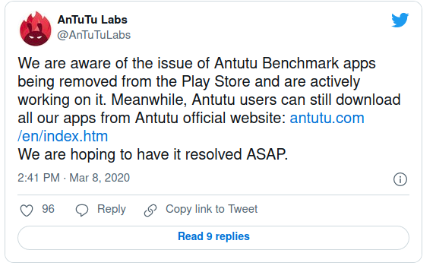

Fig 8.1 Tweet by AN TU TU organization

## 8.2 The mail sent by CEO of AnTuTu, Chen Zhao to Google

(The below mail came from the original statement with no alterations)

We received a notification email from Google on March 7th informing us that AnTuTu was one of the related publisher accounts of Cheetah Mobile, all AnTuTu apps were removed from the Play Store. But in fact, We think there is some misunderstanding about it. Antutu is NOT the related account of Cheetah Mobile!!

AnTuTu was founded in 2011, even before Cheetah Mobile, and is one of the earliest Google Play developers. Cheetah Mobile invested in us in around 2014 and became one of our shareholders since then. However, we still retain a considerable account of shares and Independent operation of the company as well as our own independent Google Play account. Cheetah Mobile has never touched our Google Play account, and AnTuTu has NOT done any promotion of Cheetah Mobile's software.

We believe that the reason for Google's misjudgment is that we purchased and used the legal services from Cheetah Mobile, so our privacy policy link used the address of cmcm.com. This is what we are working on, including changing legal supplier.

Regarding Fu Sheng being the chairman / manager of Beijing AnTuTu Technology Co., Ltd., this is because of the requirements of the investors.The company is actually operated by Beijing AnTuTu Technology Co., Ltd. Henan Branch.Fu Sheng does not actually participate in the operation or the management of AnTuTu.  Anyway, we have informed the investor Cheetah Mobile asking them to solve these problems caused by them.

We hope that Google can examine AnTuTu's account carefully and finally resolve this misunderstanding as soon as possible.

**CHAPTER 9**

**REFERNCE**

1. Refer the latest AN TU TU benchmark :

<https://www.antutu.com/en/ranking/rank1.htm>

2. For downloading the latest version of AN TU TU benchmark software : <https://www.antutu.com/en/download.htm>

3. Details regarding AN TU TU benchmark :

<https://en.wikipedia.org/wiki/AnTuTu>

4. AN TU TU banned because of cheating :

<https://appleinsider.com/articles/13/10/03/rampant-cheating->[by-android-knockoffs-prompts-antutu-to-launch-new-benchmark](https://appleinsider.com/articles/13/10/03/rampant-cheating-by-android-knockoffs-prompts-antutu-to-launch-new-benchmark)

5. Reason behind anutu banned : <https://www.thequint.com/tech-and-auto/tech-news/antutu-benchmark-test-removed-from-google-play-store>

**P**erformance ranking of processor

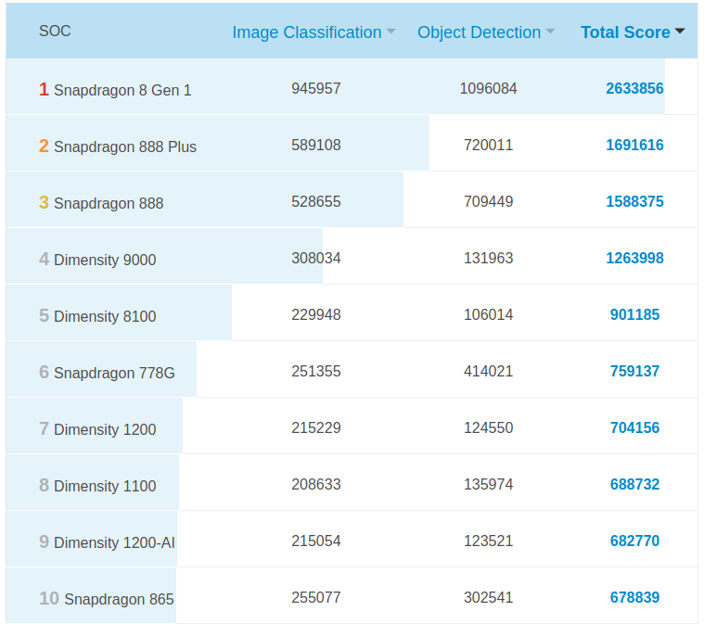

Table 9.1

**P**erformance ranking of flagship mobile phones

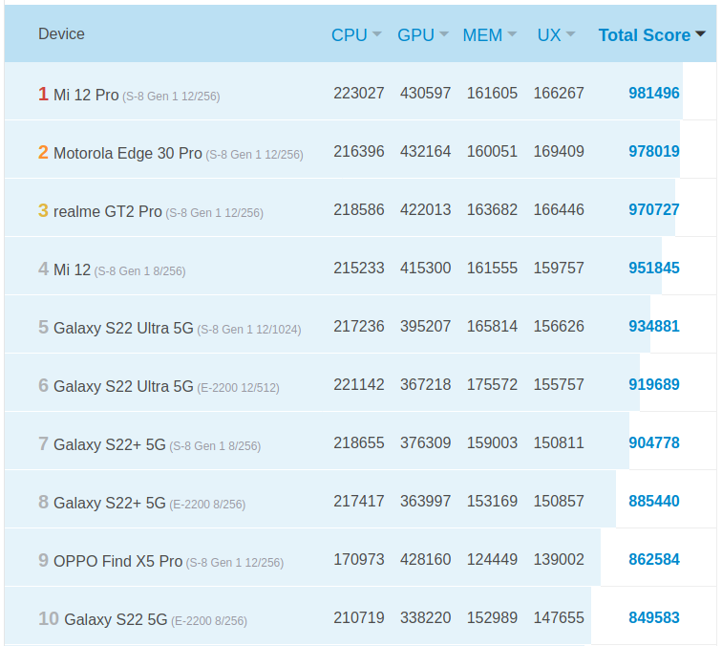

Table 9.2

**CHAPTER 10**

**CONCLUSION**

Benchmarking has consequences which are beyond the process itself: it reforms all the levels of the company.; modifies the process of manufacture of the product leads(drives) ; also reforms the hierarchical organization of the company, the product itself,There is no doubt that benchmarking is here to stay. Any company should benchmark if it wants to attain world-class competitive capability, prosper in a global economy, and above all, if it wants to survive. These trends are not an option for companies anymore; they should be done by all who want to remain competitive. All companies strive to be profitable, competitive, and successful. Benchmarking can help any company succeed-as long as it is applied correctly

Gain an independent perspective about how well you perform compared to other companies.Drill down into performance gaps to identify areas for improvement also develop a standardized set of processes and metrics.It enable a mindset and culture of continuous improvement & Set performance expectations.Benchmarks aren't perfect and don't exactly mirror real-world use. Because the results are used in reviews, some manufacturers may optimize their devices to perform faster in certain benchmark apps—effectively cheating the tests and making their phones seem faster than they are.